

**Diversity & Inclusion Action Plan Summary & Recommendations Creating a More Diverse and Equitable**

**Legal System**

**FY23 DEIA PLAN COMMITTEE**

**Past President: Cheryl Daniels**

**Attorney Kathryn Bullon**

**Attorney Michael Diaz**

**BOG Chair: Kristen Hardy**

**Attorney William Harris**

**State Bar of Wisconsin’s Diversity Statement**

**The term “diversity” has a dynamic meaning that evolves as the demographics in the state change. It is an inclusive concept that encompasses, among other things, race, ethnicity, national origin, religion, gender, gender identity, age, sexual orientation and disability. Inclusion helps to create a culture that embraces people from the widest range of talent and experience and promotes understanding and respect for all people and different points of view in the legal profession.**

**Having a welcoming Culture that people will be drawn to!**

**Mentoring our Law Students to be great Attorneys in Wisconsin**

**Reciprocate the wealth of knowledge and the experience given to you.**

**FY23 DEIA Plan Committee Recommendation Summary**

Established in 2022 after the Implementation Oversight Committee was completed. This Committee’s assignment is to review the progress made with the Action Plan, then prioritize tasks in order to continue forward movement within the State Bar. The Committee has identified 3 focus areas the State Bar can encourage the members to work on. The 3 areas include Demographic Data Metrics, Law Student Outreach, and External Outreach. Moving forward, action steps can be taken are: Green-light the Demographic Data Metrics suggestions and External Outreach tabs in the Action Plan below. Real time tracking of diversity and inclusion progress via data taken from every part of the State Bar. Reverse the funnel flow of information, enlist BOG liaisons to report progress, and increase frequency of reporting periods. Plans on how the Racial Justice Task force recommendations will interplay with our current D & I Action Plan should be forward moving.

Below the 3 areas are broken down for further recommendations.

**Demographic Data Metrics**

Recommendations:

1. **What type of data are we looking for?**
   1. The Bar should annually collect the following quantitative data:
      1. Breakdown of diversity[1] demographic information for State Bar Officers, BOG, Section Committee and Division leadership position, internal State Bar staff, and attorney members.
      2. Quantitative breakdown on publication authorship (continue to do this)
   2. The Bar should retain an individual/organization to create a survey to distribute members who have left the state to attempt diagnosis and solve problems pertaining to retention. The survey should attempt to diagnosis problems, but also identify reasons that members stay in WI.
   3. The Bar should similarly, retain an individual/organization to create a survey to distribute to WI law students to attempt diagnosis and solve problems pertaining to retention. The survey should attempt to diagnosis problems, but also identify reasons that law students stay in WI.
2. **What is the purpose of the data?**
   1. In short, to hold us accountable. State Bar leadership has made it a priority to address specific issues pertaining to diversity and inclusion that were identified in the Diversity and Inclusion Action Plan passed unanimously by BOG in 2018. We have to have a means to determine how we are doing in terms of implantation of the plan---data provides an objective way to hold the Bar accountable.
3. **What systems will we use to store and collect the data?**
   1. The Bar should be as transparent as possible regarding collection of this information.
   2. Information will be collected in the following ways:
      1. Dues Statement (revised to begin collecting more inclusive and collected for targeted information starting 2022.)
      2. BOG, and the Sections, Committees and Divisions are already encouraged to maintain demographic information.[2]
      3. Someone will need to be assigned to maintain State Bar internal hiring/retention data.
   3. The Bar could store information in one of the DIOC cloud storage folders.
   4. The data should be complied annually, so that the quantitative numbers can be available via our website for members.
      1. Unless there is a data specialist currently on State Bar staff able to digest the numbers into a easily read chart/graph, this will have to be included in future budget projections.
4. **Who will interpret the data?**
   1. See answer 3(d)(i)
5. **How to define “progress” or “success”?** 
   1. Firstly, DIOC recommends using 2018 quantitative data as a benchmark or diagnosis measurement/control baseline moving forward to measure our progress with these issues.
      1. DIOC recommends annually looking at the Bar’s demographic data to assess the effectiveness of developed programs and initiatives.
      2. The annual assessment may also have to include qualitative surveys to reach directly to members in groups that are identified as underrepresented to determine how the Bar can increase or encourage more participation.
      3. The ultimate goal is to have a Bar across the board that is representative of the various communities that we serve. To that end, we should annually look at the percentage of Bar’s demographic data and juxtapose those numbers with WI demographic statistics, with a goal of being in consistent with the WI numbers or ideally exceeding them.

**Law Student Outreach/External Outreach**

Law student outreach recommendations are in conjunction with the Greater Wisconsin Initiative outreaching all over the state.

Pre-College Education Working Initiatives

1. The pre-college education working initiatives will be tasked with increasing the diversity of Wisconsin legal profession through programming designed to target the state’s precollegiate population. To broadly increase students’ knowledge, skills, abilities, and engagement with members of the Wisconsin legal profession.
2. Health and wellness are a priority for our attorneys and Judiciary. We have many diverse attorneys and Judiciary that are doing well in the state of Wisconsin. We need to have connections throughout every group that would begin with prelaw students, law students, new diverse attorneys to the state, and existing diverse attorneys. This will develop and foster healthy relationships to help retain diverse attorneys in the state of Wisconsin.
3. Create more minority training programs for 2Ls & 3Ls to stimulate underrepresented groups’ interest in law and the legal profession. (The Diversity Clerkship Program is a caveat for 1Ls)
4. Diverse Law students need consistent meaningful touches allowing them to feel more welcome. The more activities of substance in the beginning and the end of the year will allow more networking opportunities for the diverse law students. The activities would include all groups of the State Bar. Activities like the Diversity Clerkship Recognition Reception (More networking with the student organizations).
5. Law School Working Initiatives
6. The population of attorneys in Wisconsin does not reflect the racial and ethnic demographics of the state’s residents. This trend is the direct result of the underrepresentation of people from various racial and ethnic groups within the proverbial pipeline into Wisconsin legal profession. To address causes of the lack of diversity of the Wisconsin bar we recommend
7. Adopt a Wisconsin Scholar program as a bar preparation program for underrepresented groups.
8. Create the feasibility of a loan repayment program for underrepresented groups that gain bar admission through the Wisconsin Scholar Program and practice law in the state for one year.
9. Establish coordinated pathways to admission with students who attend HBCU’s and underrepresented students who attend Wisconsin (UW system) institutions and organizations that serve significant numbers of potential law school applicants from underrepresented racial and ethnic groups.
10. Reestablish a pipeline to leadership and Judiciary.
11. A greater availability to networking throughout the state, mainly in rural areas, establishing mentorships.
12. Involving local bars in regional efforts and mentoring young lawyers
13. Collaboration needs to be made with State Bar law schools and affinity bar associations in building greater relationship with law students in order to retain them to practice law in Wisconsin.

|  |  |
| --- | --- |
| Student Racial Demographics: |  |
| White: | 78.9% |
| Black: | 6.9% |
| Hispanic: | 10.4% |
| Asian: | 2.1% |

**UW Law School MU Law School**

|  |  |
| --- | --- |
| Student Racial Demographics: |  |
| White: | 74.2% |
| Black: | 4.1% |
| Hispanic: | 8.8% |
| Asian: | 3.4% |

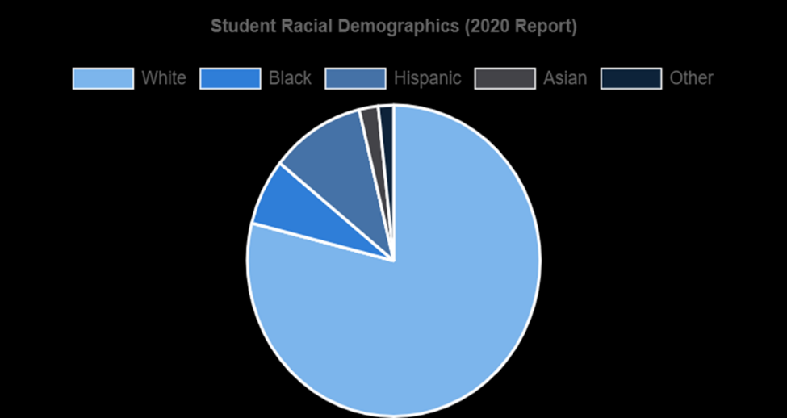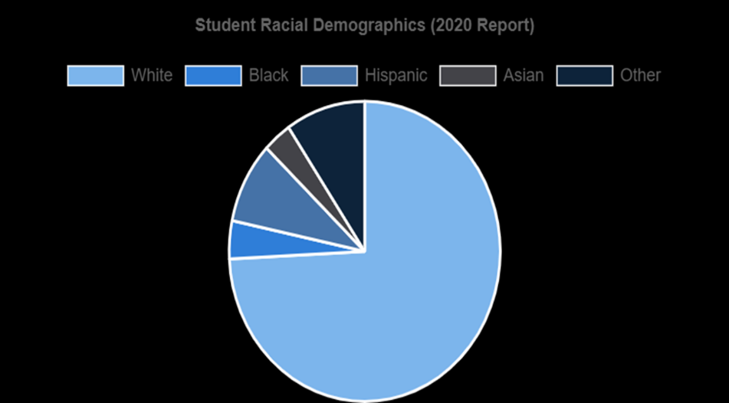

**FY23 Recommended Priority (D & I Action Plan)**

**Demographic Data Metrics**

|  |  |  |  |
| --- | --- | --- | --- |
| **Objective** | **Action Steps** | **Responsible Party** | **Progress** |
| **T1: Encourage SBW members to self-identify diverse traits** | * Chairs of Committees, Divisions, Leadership, Sections and BOG will carry the message to the members of the importance of the data collections. * Communicate why self-identification advances SBW’s strategic goal of achieving greater diversity and inclusion. * Publicize the method(s) for self-identification (ex. dues statement, My State Bar) * Develop strategies of how to move toward 100% membership self-identification | Leadership/Staff |  |
| **T2:  Develop guidelines for collecting and disseminating SBW membership diversity demographic data** | Recommendations: Highlighted in the summary. | EC/ED |  |
| **T3:  Analyze SBW membership diversity demographic data** | * Provide periodic snapshots of the diversity of SBW members. * Study and identify SBW membership diversity trends. * Track and report progress and, if necessary; alert leadership as to issues or concerns that require attention | DIOC/EC/Staff |  |
| **T4: Determine what information gaps are barriers to understanding and advancing diversity in the legal profession; develop a plan for gaining this information** | Recommendations: Highlighted in the summary. | DIOC/EC/Staff |  |
| **T5:  Establish organizational benchmarks to set baseline, periodically assess and report progress on improving diversity of Section Leaders and membership to better reflect levels of SBW memberships** | Recommendations: Highlighted in the summary | DIOC/EC/BOG |  |
| **T6:  Create a set of metrics to analyze data** | Recommendations: Highlighted in the summary. | DIOC/EC/BOG |  |
| **Strategy: Collect, maintain, and analyze demographic data of the Wisconsin court system** |  |  |  |
| **T1: Create strategies for obtaining diversity demographic data for the Wisconsin judiciary** | |  | | --- | | * Assess whether diversity demographic data   is currently collected by the Director of  State Courts, county governments,  municipalities, and/or by other outside  entities | | DIOC/EC |  |
| **T2:  Create guidelines for collecting, managing, and disseminating diversity demographic data for the Wisconsin judiciary** | Recommendations: Highlighted in the summary | ED/EC/BOG |  |
| **T3:  Analyze Wisconsin judiciary diversity demographic data** | * Provide periodic snapshots of the level of diversity in the Wisconsin judiciary. * Study and identify diversity trends in the Wisconsin judiciary. * Track and report progress and, if necessary, alert leadership as to issues/concerns that require attention | EC/DIOC |  |
| **Strategy: Collect, manage, and analyze law student and faculty diversity demographic data of Wisconsin law schools** |  |  |  |
| **T1: Create strategies for obtaining diversity demographic data for law students and faculty of UW and Marquette law schools** | Assess whether diversity demographic data is currently collected by the law schools and/or by other outside entities (ex. National Association for Law Placement “NALP”, ABA Standard 509 Report) | DIOC/EC |  |
| **T2:  Assign responsibility for collecting, managing, and disseminating demographic data for law schools** | * Identify who is responsible for collecting and disseminating law student and faculty diversity demographic data.   Adopt and periodically update bar policy for managing and disseminating law student and faculty diversity demographic data | ED/EC/BOG |  |
| **T3: Analyze law student and faculty membership diversity demographic data** | * Provide periodic snapshots of the level of student body and faculty diversity. * Study and identify student body and faculty diversity trends.   Track and report progress and, if necessary, alert leadership as to issues or concerns that require attention | DIOC/EC |  |

**D**

**Law Student Outreach**

|  |  |  |  |
| --- | --- | --- | --- |
| **Objective** | **Action Steps** | **Responsible Party** | **Progress** |
| **Rural area Outreach** | * Utilizing resource within the Local Bars and Affinity Groups in rural areas |  |  |
| **Reestablish pipelines to leadership and Judiciary** | * Analyzing the past pipelines. Utilizing the programs with proven success. |  |  |
| **Law School Working Initiatives** | * Adopt a Wisconsin Scholar program as a bar preparation program for underrepresented groups. * Create the feasibility of a loan repayment program for underrepresented groups that gain bar admission through the Wisconsin Scholar Program and practice law in the state for one year. * Establish coordinated pathways to admission with students who attend HBCU’s and underrepresented students who attend Wisconsin (UW & MU) institutions and organizations that serve significant numbers of potential law school applicants from underrepresented diverse groups. |  |  |
| **Increase Law Student interaction** | * Connect with a similar practice area student organization or with student affinity groups. Host events sponsored by these groups or invite them to upcoming section events. * Participate in minority clerkship or fellowship programs i.e. Diversity clerkship program * Meet with and support law student leaders and student affinity groups. * Advertise in law student association publications directed toward women, first generation, minorities, LGBTQ+, and disabled students. * Communicate the sections diversity and inclusion goals to deans, professors, career services professionals, and diversity & inclusion professionals; ask for assistance in identifying and referring promising women, first generation, minority, LGBTQIA+, and disabled students. * Utilize student liaison |  |  |

**External Outreach**

|  |  |  |  |
| --- | --- | --- | --- |
| **Objective** | **Action Steps** | **Responsible Party** | **Progress** |
| **Strategy: Increase diversity & inclusion in the Wisconsin legal profession and the judiciary** |  |  |  |
| **T2: Increase representation of diverse attorneys in the legal profession in Wisconsin** | * Research and develop tools/best practices that can be used to market Wisconsin to diverse candidates and distribute to legal employers statewide (incorporated from D&I report). * Implement SBW partnerships with the various affinity groups and Marquette and UW Law Schools to attend nationwide legal job fairs, to promote WI law schools and legal community. * Create a mentoring program for out-of-state diverse law students with diverse members of the SBW in the law students’ areas of interest in WI -- use affinity group partnerships and relationships. * Research existing law firm/corporation diversity pipeline programs to determine best practices and strategies. * To increase the pipeline of students of color in the legal profession, provide SBW support to local bar programs like the Eastern District of Wisconsin Bar Association mentoring program and middle school and high school career programs like Marquette Law School Summer Institute and UW’s UW Plus program, increasing the visibility of the legal profession in Milwaukee schools. | DIOC/Staff |  |
| **T3: Support the advancement of women and minorities into law firm leadership** | * Research effective programs developed by other associations, legal organizations, and law firms. * Create a model D&I plan for law firms and organizations to adapt, resulting in the retention and advancement of diverse lawyers. * Form a network of thought leaders and other experts to develop actionable steps. Identify cultural, institutional, and other barriers to advancement. * Create a plan to educate and improve law firm culture that ensures a broad selection of firm leaders, sustains and nurtures diverse partners, and promotes meaningful mentoring. | DIOC/Staff |  |
| **T4: Encourage, support, and promote the increase in the number of diverse attorneys in the Wisconsin judiciary** | * Increase SBW outreach to diverse attorneys (use affinity group partnership) to communicate regarding judicial vacancies (including court commissioner positions) and opportunities. * Create a mentoring program for current diverse judges and court commissioners to identify and mentor diverse attorneys to become judges and court commissioners. * Host networking sessions with diverse judges and law students to foster interest in the judiciary | DIOC/Staff/Public Affairs/Affinity Bar Leaders |  |
| **T5: Increase retention of diverse attorneys in law firms, government organizations, corporations, and nonprofits** | * Conduct research and partner with law firms, government organizations (county & local), nonprofits, and corporations to determine best practices for retaining diversity in various fields of employment. Compile information into a toolkit and publish on WisBar.org. | DIOC/Staff |  |

1. Diversity demographics are identified as follows consistent with the State Bar’s dynamic definition of diversity: race, ethnicity, national origin, religion, gender, gender identity, age, sexual orientation disability. 2 Most recently, the Section leadership distributed a form to DIOC for our thoughts on how to not only collect demographic information at the end of the term/year, but also how to think in advance on planning for the year while keeping D&I on the forefront. We need to encourage the other committees and divisions to use this form.
2.