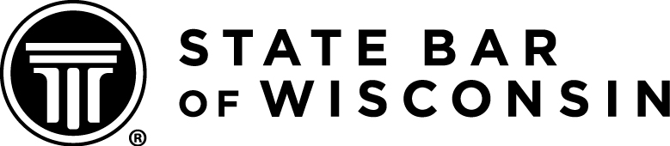

The State Bar of Wisconsin is pleased to announce that Wisconsin has been selected to host the 2014 National Mock Trial High School Championship. The event will be held May 9-11, 2014, in Madison. Dane County judges have generously allowed the use of their courtrooms and the WI justices have graciously allowed the use of the Supreme Court Hearing Room for the championship round. Thank you to each of them!

National Mock Trial will draw hundreds of students, teachers, attorneys and judges from across the country for this multi-day event. It will give Wisconsin a wonderful opportunity to highlight their courts, legal system and community.

The State Bar would like to invite all of its members to share in making this a positive, memorable, learning experience for students. We also want to extend a warm welcome to all the judges, attorneys and families from around the country who will be visiting Wisconsin. Hundreds of volunteers will be needed for various activities and events. A list of committees is below.

We would welcome anyone who would like to get involved in the planning and running of this event. Please check below if you are interested in volunteering in a specific area:

☐Fundraising
☐Event planning (welcome events; lunches/breakfasts;banquet)
☐Recruiting judges/attorneys to judge the championship
☐Judge tournament rounds
☐Awards (trophies; T-shirts;photography;program)
☐Volunteers (staffing events;courthouse;courtrooms)

Please email this page to lrecoordinator@wisbar.org or contact Marsha Varvil-Weld at (608)250-6191 to volunteer or for additional information.

Fundraising will be necessary to support this event. If you would like to make a tax-deductible donation, please make a check out to:

National Mock Trial Fund
c/o The Wisconsin Law Foundation
5302 Eastpark Boulevard
Madison, WI 53707-7158
Thank you!!

